Anonymous

Full Paper Title

Abstract
In this paper, the formatting requirements for the Conference of the International Association of Maritime Economists (IAME 2017) are described. The full paper shall be written in compliance with these instructions. Please review this document to learn about the formatting of text, table captions and references. The conference proceedings will be published in an electronic format. Papers should be uploaded on the IAME Conference Management System website as [.doc] or [.docx] file. The first version of the paper for review should be anonymous. Once the paper has been reviewed and accepted for the conference, then a version containing the authors names (where Anonymous occurs in this template) should be submitted, with any revisions suggested by the reviewers. An abstract not exceeding 200 words should appear on the top of the first page, after the title of the paper in a section titled "Abstract" (without section number). It should be written so as to motivate readers to continue and explore the article.
Keywords: (4-6 keywords) keyword 1, keyword 2, keyword 3, keyword 4.

1. Introduction
It is expected that authors will submit carefully written and proofread material. Careful checking for spelling and grammatical errors should be performed. The number of pages of the paper should be from 10 to 25, including bibliography, appendixes, tables and any other relevant material. Any papers longer than 25 pages will not be accepted.
Papers should clearly describe the background of the subject, the authors’ contribution, including the methods used, results and concluding discussion on the importance of the work from both scholarly and managerial perspectives.

2. Text Format
A uniform appearance will assist the reader to read paper of the proceedings. It is therefore suggested to authors to use the example of this file to construct their papers.
If you are copying and pasting text from another document in which the formatting is different, it’s highly recommended to use the paste special function in MS Word and choosing the "Keep Text Only" option.

2.1 Language
When writing the paper please remember to use either British, or US, spelling but not a mix of the two, i.e., if you choose British spelling it would be colour not color; behaviour (behavioural) not behavior; [school] programme not program; [he] practises not practices; centre not center; organization not organisation; analyse not analyze, etc.

2.1.1 Acronyms
All acronyms should be spelled out the first time they are introduced in text or references. Thereafter the acronym can be used if appropriate, e.g. 'The work for the Organization of United Nations (OUN)...'. Subsequently, 'The OUN studies on...', in a reference ... (Organization of United Nations [OUN] 1989).

3. Equations, Tables and Figures
Equations must be written preferably with the same word processor used for the rest of the text, without hand written symbols in order to aid legibility. Equations must be numbered sequentially with their numbers in parenthesis and right justified.
Tables and figures must be embedded in the paper text, close to the location of their first appearance. All tables and figures must be referred to in text as follows: Figure 1, Table 1, i.e. 'As seen in Table [or Figure] 1 ...' (not tab., fig. or Fig). All figures must be numbered in the order in which they appear in the paper (e.g. Figure 1, Figure 2). Please ensure that tables do not split over the page.

3.1. Titles of tables and figures
Each table should have a descriptive title (using the current style) and each column an appropriate heading. Each table and/or figure must have a title that explains its purpose without reference to the text. Do not type the caption to a figure on that figure; the legends to any illustrations must be typed separately following the main text and should be grouped together. Table legends must be placed above the table; diagram or figure legends below the diagram or figure.

3.2. Examples of tables and figures
Table 1 – Table legend
Source: IAME 2017

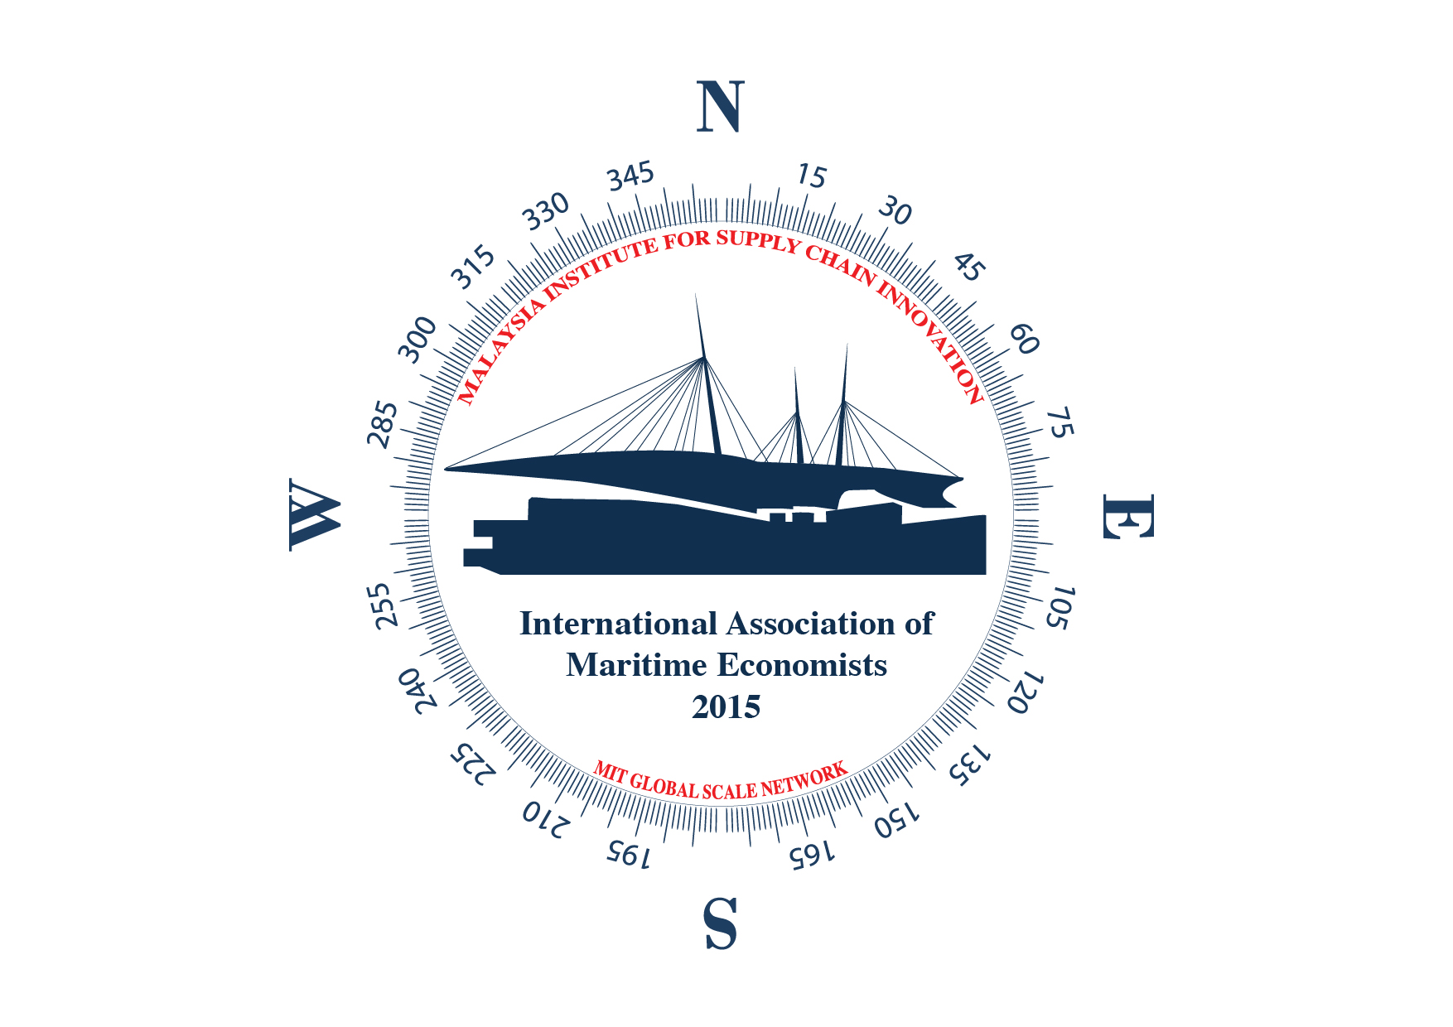
Figure 1 – Figure legend
Source: IAME 2017

4. Citations
The whole citation should follow the Harvard style, enclosed within parentheses (author surname, year) if not a natural part of the surrounding sentence; the year should be enclosed within parentheses if the names do form a natural part of the surrounding sentence. Citations of works by two authors should have ‘and’ (not an ampersand) between the names. Citations of works by three or more authors should have the first author followed by et al in italics with no trailing stop.
In-text lists of references should be listed in chronological order (e.g. author1, 2002, author2, 2004, author3, 2008). Publications by the same author(s) in the same year should be identified with a, b, c (e.g. 2008a, 2008b) closed up to the year.
A reference list should appear at the end of the paper under the heading "References". All the references should be arranged in alphabetical order. Please follow the examples below (cf. References).

Acknowledgements
Any acknowledgements authors wish to make should be included in a separate headed section at the end of the manuscript but before the list of references. This should only be added after the blinded paper is reviewed and not before it is reviewed as it may suggest the location or name of the author(s).

References [please choose appropriate style for the type of reference]
[For an article in a journal] GOSS, R. O., 1990, Economic policies and seaports: strategies for port authorities. Maritime Policy and Management, 17(4), 273-287.
[Book] FRANKEL, E. G., 1987, The World Shipping Industry (London, U.K.: Croom Helm).
[Chapter in a book] FRIESZ, T. L., 1981, The multiobjective optimization in transportation: the case of equilibrium network design. In: Organizations: Multiple Agents with Multiple Criteria, edited by J. N. Morse. Lecture Notes in Economics and Mathematical Systems, Vol. 190 (NewYork: Springer-Verlag), pp. 116-127.
[Report, proceedings, and unpublished literature (a)] TAN, H., GERSHWIN, S., and ATHANS, M., 1979, Hybrid optimization in urban traffic networks. MIT Report Dot-TSC-RSPA-79-7.
[Report, proceedings, and unpublished literature (b)] ASAKURA, Y., and SASAKI, T., 1990. Formulation and feasibility test of optimal road network design model with endogenously determined travel demand. Proceedings of the 5th World Conference on Transport Research, Yokohama, Japan, July, pp. 351-365
[Report, proceedings, and unpublished literature (c)] YANG, H., BELL, M. G. H., and MENG, Q., 1997, Equilibrium zone reserve capacity under network capacity constraints. Working paper, The Hong Kong University of Science and Technology.
[Newspaper or magazine] SMITH, A., 1996, Labour ditches plans to re-regulate buses. Financial Times, 30 December.
[Internet source (with title, date of access and the universal resource locator in full)] UNO, Charter of the United Nations (Preamble), Date of access: 21/11/2012. http://www.un.org/en/documents/charter/preamble.shtml.
[Government legislation (a)] US CONGRESS, Senate Committee on Foreign Relations, 1956, The Mutual Security Act of 1956, 84th Congress, second session, report 2273.
[Government legislation (b)] UNITED KINGDOM PARLIAMENT, Committee on the Working of the Monetary System [Radcliffe Committee] 1960, Principal Memoranda of Evidence , vol. 2, Cmd 1958.
[Government legislation (c)] UNITED NATIONS GENERAL ASSEMBLY, Secretariat for Economic Affairs, 1951, Methods of Financing Economic Development in Less Developed Countries, report II B2.

