Paper title for your research and investigation

Author KIKAI*, Author YAMA* and Author UMI**

*Japan Society of Mechanical Engineering

35 Shinanomachi, Shinjuku-ku, Tokyo 160-0016, Japan

E-mail: journal@jsme.or.jp

**Department of Mechanical Engineering, Kikai University

35 Shinanomachi, Shinjuku-ku, Tokyo 160-0016, Japan

Keywords : Term1, Term2, Term3, Term4, Term5 (Show three to five keywords)

# Introduction

The short paper should be described not in excess of two pages with figures. The subject of the paper should be stated clearly, together with its scope and objectives. Then, the methods, equipment, results and conclusions in the paper should be stated concisely in a sufficiently logical manner. You can also use equations with free format. Reference number in the text should be enclosed in brackets [1] [2]. The discussion on the results may also be stated to emphasize their importance appropriately. -----------------------------------------------------------------------------------------------------------------------------------------------------------------------------------------------------------------------------------------------------------------------------------------

Table 1 Physical properties of air at atmospheric pressure.

|  |  |  |  |  |  |  |  |
| --- | --- | --- | --- | --- | --- | --- | --- |
| [oC] | [kg/m3] | [J/(kg·K)] | [Pa·s] | [m2/s] | [W/(m·K)] | [m2/s] |  |
|  |  | ×103 | ×10-5 | ×10-5 | ×10-2 | ×10-5 |  |
| 0 | x.xxxx | x.xxx | x.xxx | x.xxx | x.xxx | x.xxx | x.xxx |
| 10 | x.xxxx | x.xxx | x.xxx | x.xxx | x.xxx | x.xxx | x.xxx |
| 20 | x.xxxx | x.xxx | x.xxx | x.xxx | x.xxx | x.xxx | x.xxx |
| 27 | 1.1763 | 1.007 | 1.862 | 1.583 | 2.614 | 2.207 | 0.717 |
| 30 | x.xxxx | x.xxx | x.xxx | x.xxx | x.xxx | x.xxx | x.xxx |
| 100 | x.xxxx | x.xxx | x.xxx | x.xxx | x.xxx | x.xxx | x.xxx |

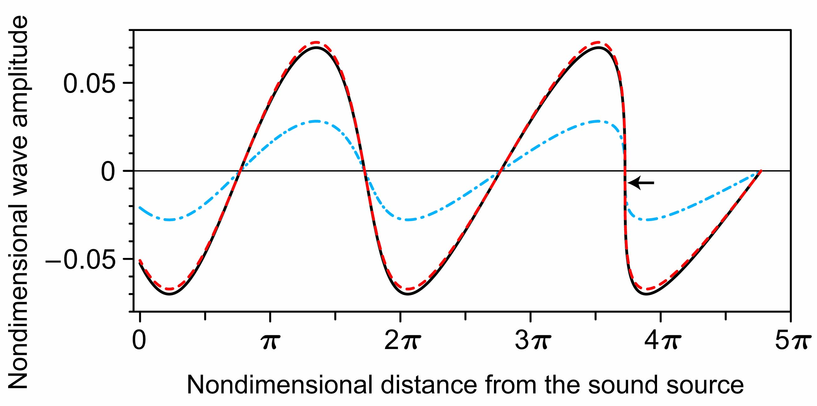

Fig.1 The nonlinear propagation of plane acoustic wave.

# Conclusions

References

[1] Ning, X., and Lovell, M. R., “On the Sliding Friction Characteristics of Dampers,” ASME J. Tribol., 124(1) (2002) pp. 5-13.

[2] Ando, Y., “Applying Microfabrication Technologies to Bogie Structures,” Proc.STECH2013, (2013) pp. 6-7.